**LAB REPORT #1** Name: Owais Rao

**Experiment No.1** Roll No.:22L-7638

Class: BSEE-1A2

**Introduction:-**

In this experiment, we learnt the concept and step by step working of Visual Studio. Visual Studio is an Integrated Development Environment (IDE) developed by Microsoft to develop GUI, console, cloud and web services etc. With the help of this IDE, you can create managed code as well as native code. It uses the various platforms of Microsoft software development software like Windows store, Microsoft Silverlight, and Windows API, etc. It is not a language-specific IDE as you can use this to write code in C#, C++, VB (Visual Basic), Python, JavaScript, and many more languages.

**Objective:-**

* To be able to use Visual Studio for compiling simple C++ programs.
* To be able to understand I/O environment in C++.
* To get familiar with data types.
* To be able to understand and solve a programming problem using C++ arithmetic expressions.

**Procedure:-**

With the help of lab manual, I was able to write codes for given exercises. They are as follows with their outputs:-

**Exercise 1:-**

#include <iostream>

using namespace std;

void main()

{

cout<<”************************************************************\n”;

cout<<”Rao Muhammad Owais\t”<<”22L-7638\t”<<”BSEE\t”<<”1st Semester\n”;

cout<<”************************************************************\n”;

}

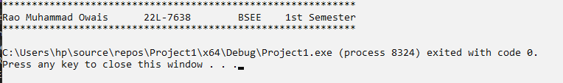

**Exercise 2:-**

#include <iostream>

using namespace std;

void main()

{

int A;

int B;

int C;

cin>>A>>B>>C;

cout<<A<<”\t”<<B<<”\t”<<C<<”\n”;

cout<<A*2<<”\t”<<B*2<<”\t”<<C*2<<”\n”;

cout<<A*3<<”\t”<<B+2<<”\t”<<C+2<<”\n”;

}

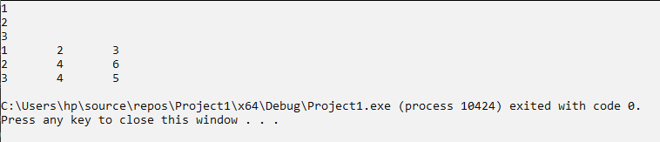

**Exercise 3:-**

#include <iostream>

using namespace std;

void main()

{

cout<<” *\n”;

cout<<” **\n”;

cout<<” ***\n”;

cout<<” ****\n”;

}

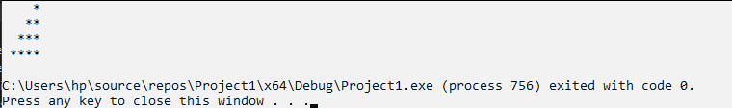

**Issues:-**

No issues were faced during the activity.

**Conclusion:-**

* I was able to understand the working of Visual Studio.
* I was able to solve programming problems using C++ arithmetic expressions.

**Applications:-**

* There are many applications of C++ in the fields of engineering and medicine as well.
* MRI scans in medical field and CAD/CAM systems in the engineering fields for construction and mining purposes use C++.
* C++ is also used in browsers and GUI applications.
* Visual Studio is used to develop computer programs, as well as websites, web apps, web services and mobile apps.